|  |
| --- |
|  |
| Saving Soldiers |
|  |
| Version #1.2.0  All work Copyright © 2012 by G Studio.  All rights reserved. |
| **Vishal Guleria 300813391** |
|  |



|  |
| --- |
| March 17, 2016 |

**Table of Contents**

Table of Contents

**Version History** 3

Game Overview 4

Camera 4

Controls 4

Interface Sketch 5

Menu and Screen Descriptions 7

Game World 8

Characters/Objects 8

Enemies 8

Scoring 8

# **Version History**

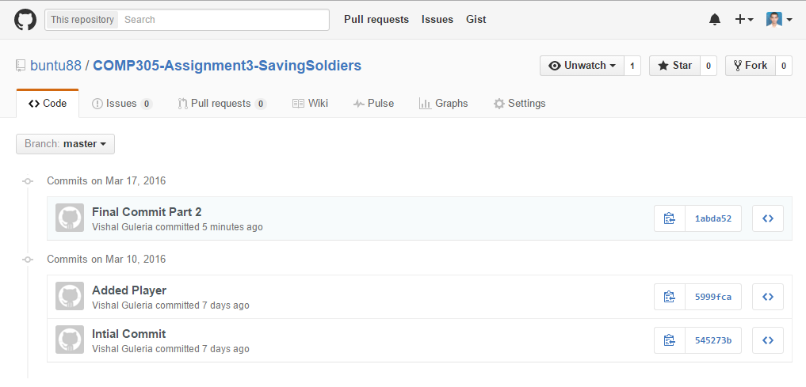

GitHub: https://github.com/buntu88/COMP305-Assignment3-SavingSoldiers.git

# Game Overview

This application is a 3D third person game designed using Unity. In this game, fundamental article is a Plane in a battlefield to bring back abandoned soldiers. Plane has to fly through some obstructions and challenge to achieve its goal. Flight have basic first person control like acceleration, airbrake, turning left and right. to move forward.

# Camera

This is 3D game, so orthographic third person view is used for the camera.

# Controls

The controller for this game would be keyboard keys. The gamer can use the arrow keys i.e. “Right” In this diversion, Up, Right, Left and Down key or W, A, D and S are the principle controls to make it easy to understand. The diverse catches are play again catch.

**Play Again:** - After the game is over, player has an alternative to play the game again by tapping on play again catch symbol.

# Interface Sketch

Main Screen

1. Take off for the mission



2. Enemy Planes as obstructions



3. Landing for soldiers rescue mission.



Finish Screen

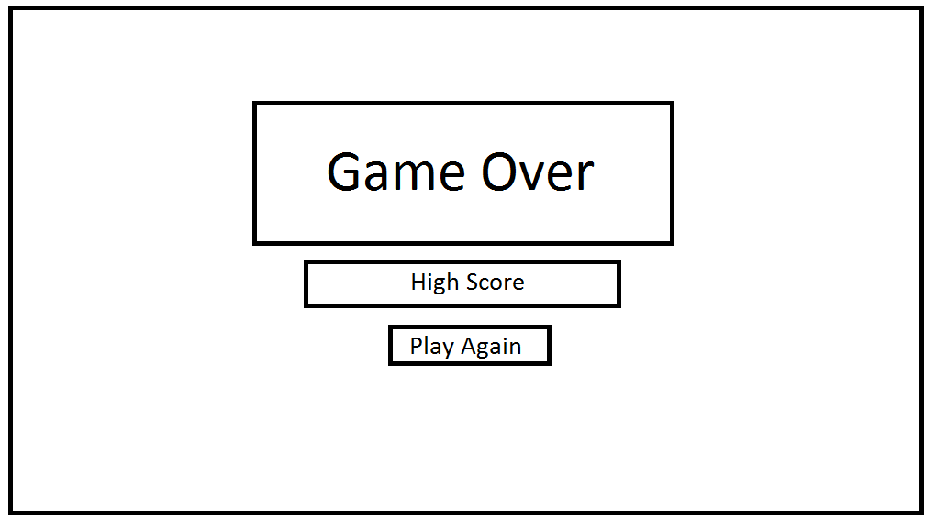

# Menu and Screen Descriptions

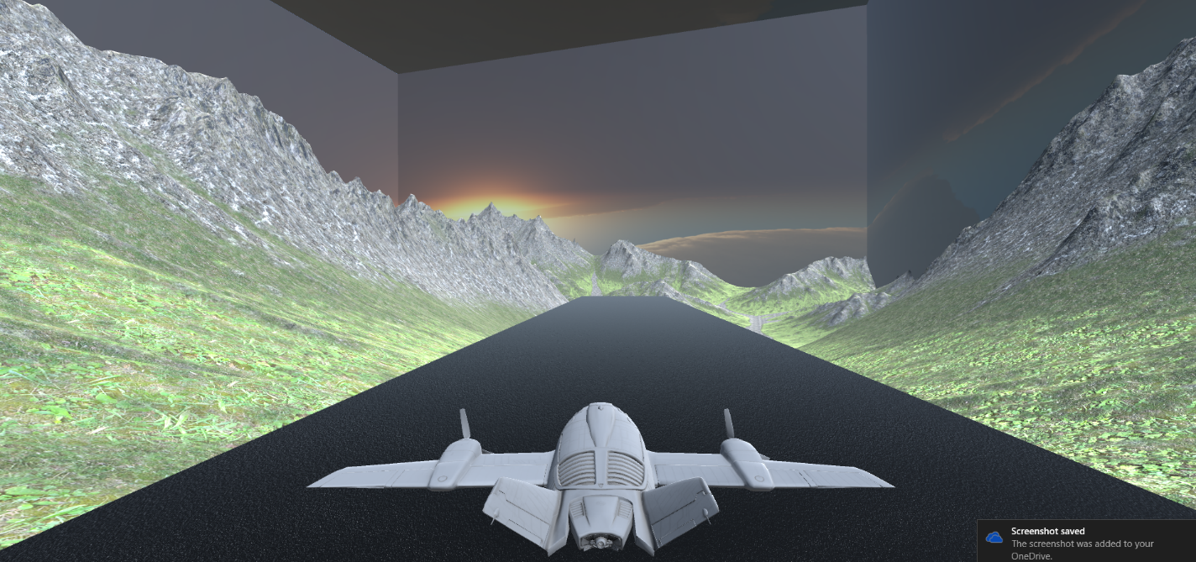

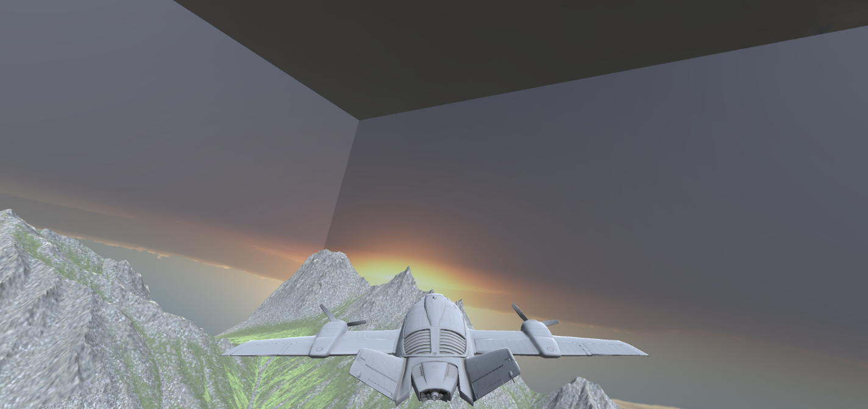

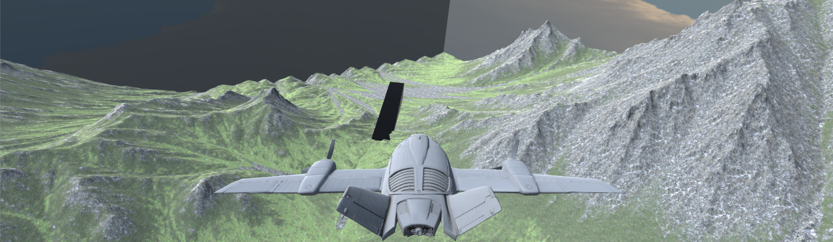

**Finish Screen**

If the player destroyed for 5 times, game gets over. Player can play again by pressing try again button.

# Game World

In this diversion, principle foundation is the battlefield. The whole amusement has 3D third person perspective and obstructions in it. Primary symbol is a Plane. Player sees everything from the third person view. As the plane flies ahead, it confronts numerous obstructions like missiles, fighter planes as impediments particular to every level. Player needs to keep away from all these with a specific end goal to survive and gather the soldiers from the 1 point and bring back to the destination.

# Characters/Objects

Plane

The main character or AVATAR in this game is a Plane. Player’s main goal is to control the acceleration, airbrake, right and left movement of plane with the Up, Down, right and left key on the keyboard to get points by taking truck to the abandoned soldier and bring back home.

# Enemies

Missiles and enemy planes

Missiles and enemy planes are there to stop the player from getting to the soldiers.

# Scoring

Lives

One life gets reduced each time savior plane get destroyed. Player has 5 lives in starting.

Scores

100 scores are awarded for each obstacle to cross unharmed.